**TITLE: HOSPITAL MANAGEMENT SYSTEM**

AIM :

* Patients are able to take appointment with their desired Doctors and choose other facilities.
* Creating an interface for hospital management system for the patients and the staff.
* Staff is able to fetch information about the patients and generate Bill for the concerned patient when they are discharged.

OBJECTIVES :

* To achieve a system that successfully creates two interfaces for a patient and the staff.
* To manage the occupancy data of a hospital that includes data about occupied beds, available doctors and patient details using a SINGLY LINKED LIST.
* To generate a bill for patients that have lived in the hospital or have come for general check-up.

METHODOLOGY:

* Workflow Diagram :

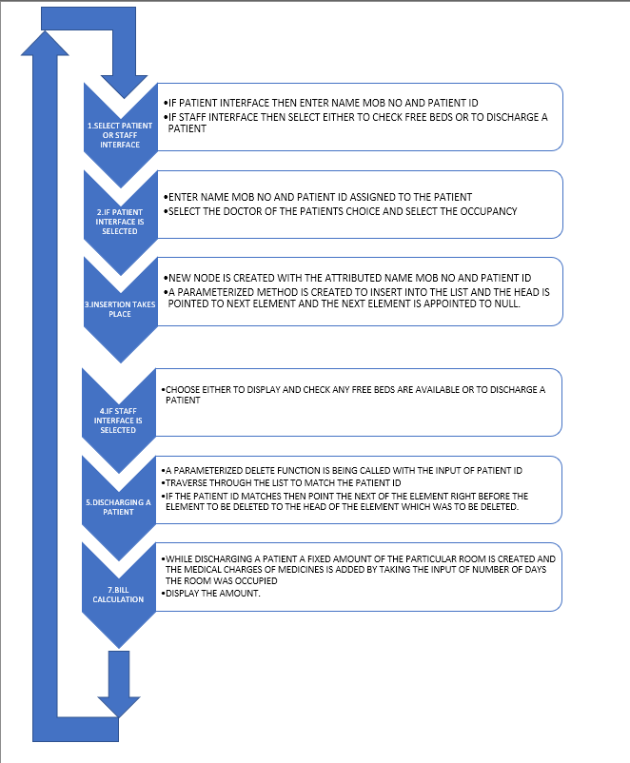

A singly linked list (named Single and Double in this project) helps in storing the patient details in a single bed occupancy and double bed occupancy respectively. The code begins by

1)Creating two interfaces Patient and Staff interface.

2)Entering and verifying patient data and allotting him a bed (Single or Double) depending on his choice or availability. (Given an option of a regular check-up as well and charging the fee according to the doctor that user has chosen.)(Insertion)

3)Verifying data means checking whether the entered details like mobile number. patient id are valid or not. Also ensuring that each patient has a unique 4 digit alphanumeric patient id.( Traversing and Searching)

4)In the staff interface, the staff has access to patient details that has been lexicographically sorted using selection sort.(Sorting)

5)The staff can discharge the patient from the hospital and then print the bill payable by the user. (Deletion)

RESULTS :

A dynamic error free program that constantly keeps taking input from user without generating an infinite loop.

An efficient way of managing a small scale hospital on your fingertips by creating a model that inputs patient details, outputs the bill and also provides the other doctor details.

Certain results of output are :

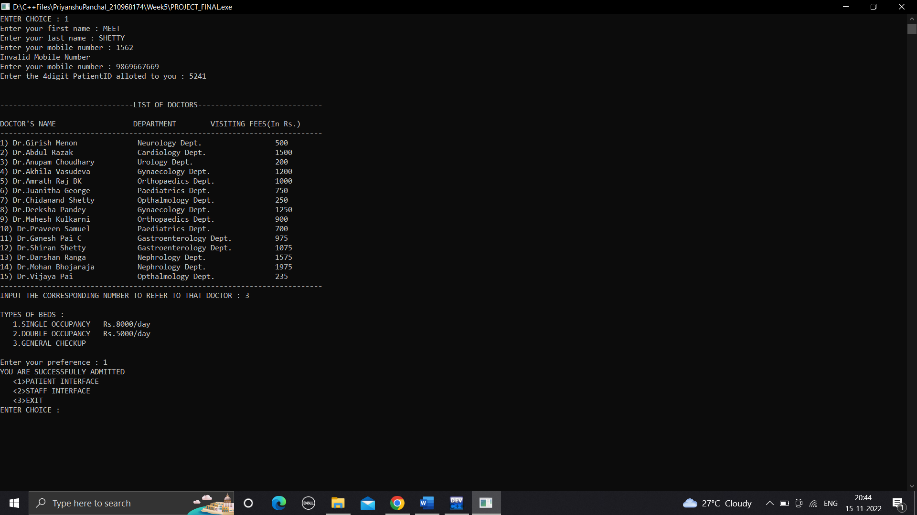 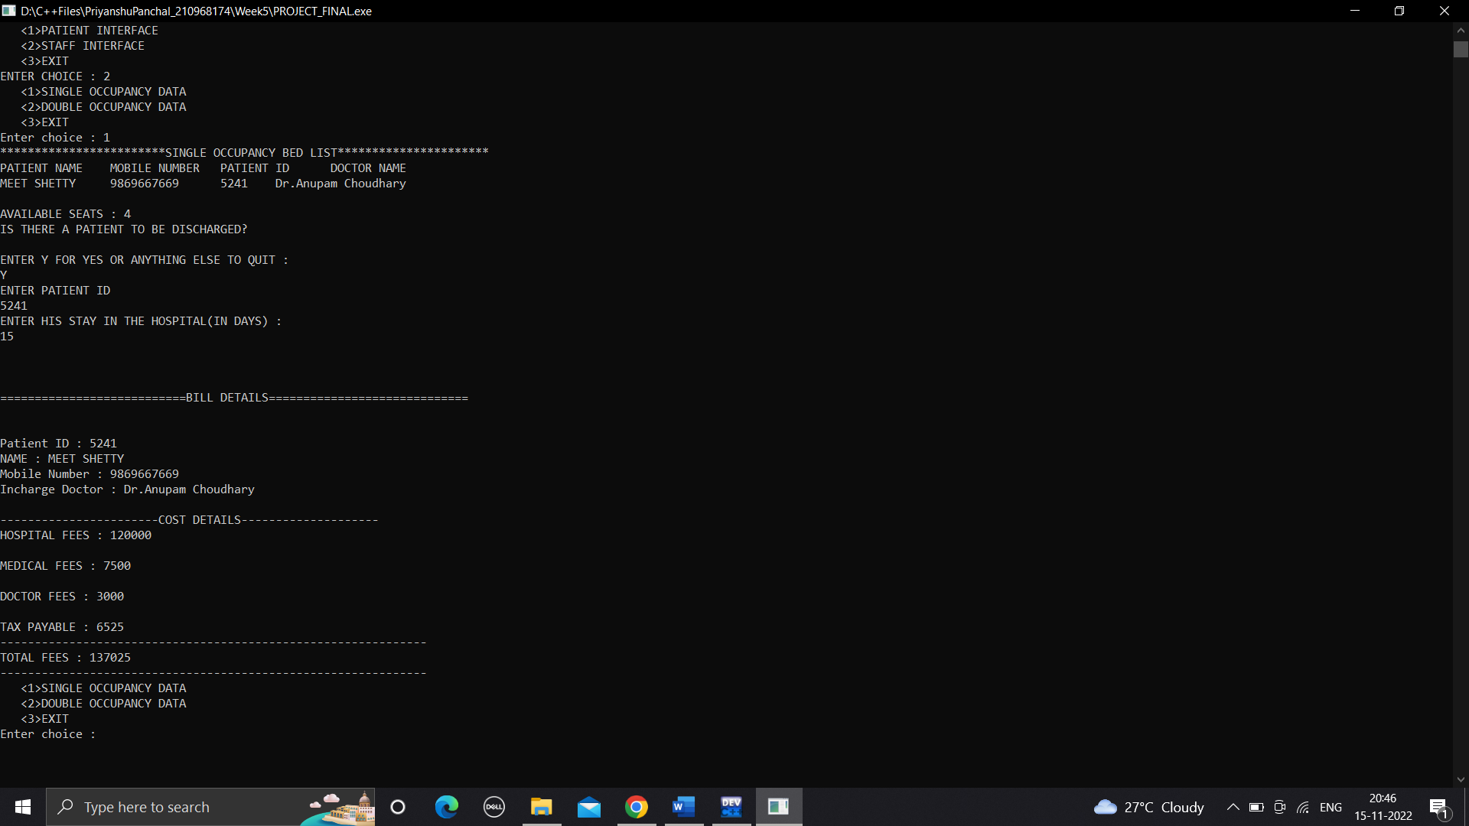

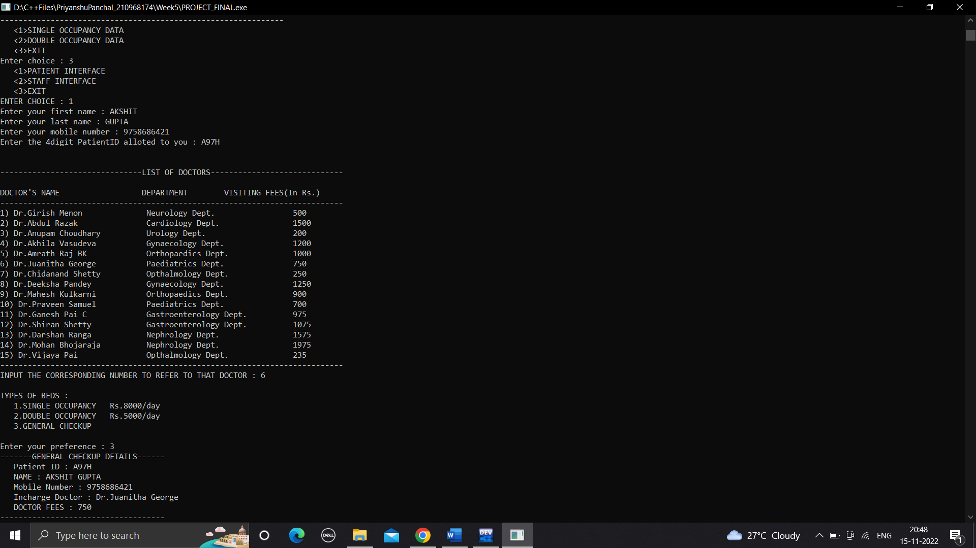 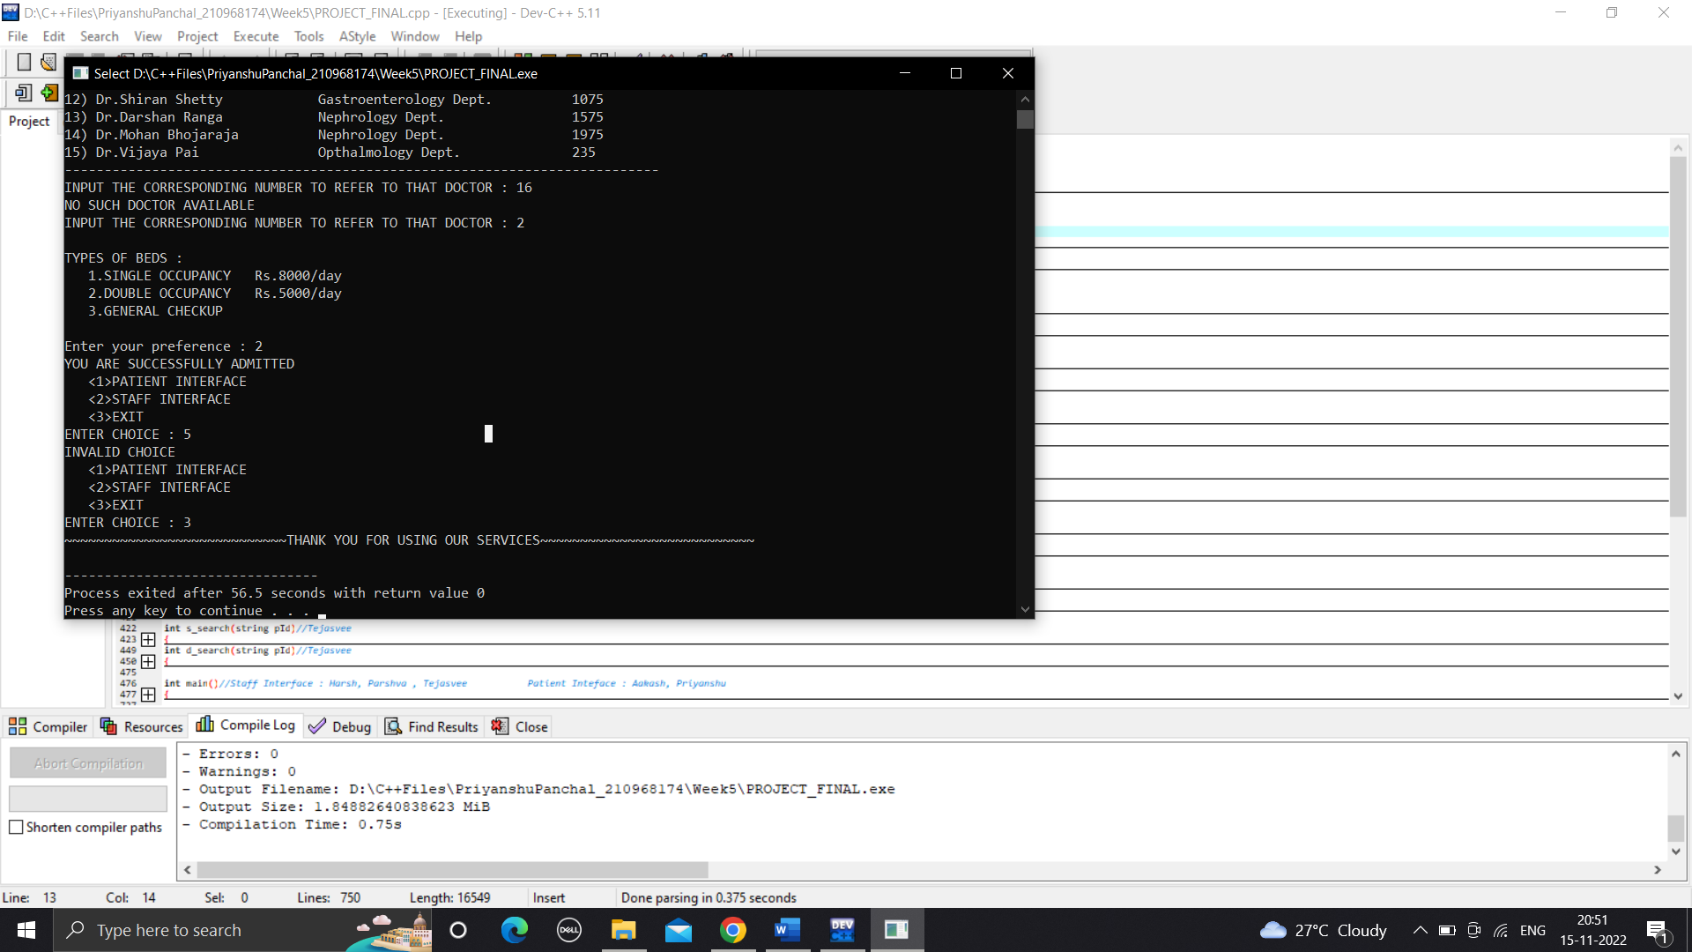

CONCLUSION :

To understand the importance and real world application of linked lists was the main outcome of this project . Implementing the concepts of insertion, deletion and sorting etc learnt in class in the code and designing a code from scratch.

Overall a fun journey dealing with linked lists in hospital management system thus a successful attempt at designing and managing rather coding the stystem.

REFERENCES :

1. <https://www.geeksforgeeks.org/>
2. stackoverflow.com
3. https://manipal.edu/mu.html (Dataset)